Functional Specification Document
Automotive Data Orchestration Platform

DOCUMENT VERSION <1.0>
<01/09/2023>

AUTHORS
Name | Role | Department
Ankit Arora | SW Engineer | Engineering

DOCUMENT HISTORY
Date | Version | Document Revision Description | Document Author
01/09/2023 | 1.0 | Updated document with software and functional specification. | Ankit Arora

APPROVALS
Approval Date | Approved Version | Approver Role | Approver
01/09/2023 | 1.0 | Project Manager | Vimin

Table of Contents
1. Introduction 3
1.1 Purpose of the document 3
1.2 Project Scope 4
1.3 Terms/Acronyms and Definitions 4
2. System/ Solution Overview 5
2.1 Context Diagram/ Interface Diagram/ Data Flow Diagram, Application Screen Flow, Sitemap, Process Flow 6
2.3 Dependencies and Change Impacts 9
3. Functional Specifications 9
3.1 <User Flow> 12
4. System Configurations 21
4.1 Backend Setup 21
4.2 Frontend Setup 22
6.1 Exception Handling/ Error Reporting 24
7. References 25
8. Open Issues 25
9. Miscellaneous 25
9.1 Introduction To ASN.1 25
9.2 Types of messages 27
9.3 Format Of Messages After Decoding 28
9.4 Map & SPAT Data Creation Summary 31

Introduction
Automotive Data Orchestration Platform ingest data from different sources including Vehicles, Pedestrians and Vehicle infrastructure and RSU (Road Side Unit), etc. and display in dashboard for user analysis. It also shows vehicle, emergency vehicle and pedestrian movement and assist them with directions or alerts.

Purpose of the document
The Functional Specification Document is a document that provides detailed information on how the system solution will function and the requested behavior which includes detailed functional requirements including use cases, system inputs and outputs, process flows, diagrams, and mock ups.

Project Scope
This application aims to be used by multiple stakeholders in the Automotive industry. Its sole purpose is to help the targeted users in analyzing the status of Vehicles/pedestrian/Emergency vehicles on real time. The administrator mode of the application will help the user to track the real-time information of their on-road vehicles.

Terms/Acronyms and Definitions

Term/Acronym | Definition
vRSU | Various road side units
MQTT | Message queue telemetry transport
HTTP | Hypertext transfer protocol
API | Application programming interface
UPER | Unaligned packed encoding rules
JER | Json encoding rules
BSM | Basic safety message
PSM | Personal safety message
EVA | Emergency vehicle alert
SPAT | Signal phase and timing
RSA | Roadside alert
UI | User interface
ASN | Abstract syntax notation
JSON | JavaScript object notation
REST | Representation State

System/ Solution Overview
Multiple layers are present in the following solution, and they are connected to one another using HTTP services/WebSocket
- Dashboard
- Backend
- Verizon Server
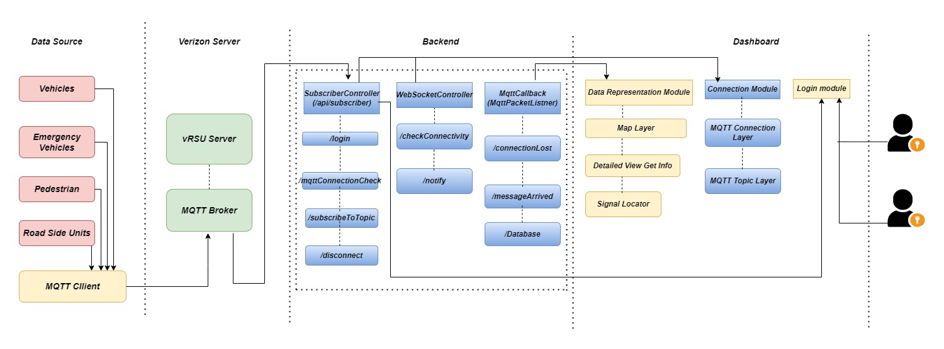
- Data Source
- Dashboard: Here, users can interact with the application using the user interface platform. Below are the modules of Dashboard.
Data Representation Module: Under this module, all the data processing done for eg., getting decoded data in WebSocket and displaying that information in Map Layer, Detailed view, Get info and Signal location.
Connection Module: Under this module, all the connection made for ex WebSocket connect. MQTT connection using HTTP Rest APIs connection
Login Module: This module is entry for all the user having valid user credential and after authentication, they are redirected to other modules.
- Backend: IT is the layer where all the data processing is done. Below are the rest services mentioned in table.
Backend Rest Controllers | Rest Endpoints | Description
SubscriberController | /login | Used to login to dashboard UI using username and password.
 | /mqttConnectionCheck | It is a rest endpoint service used to connect MQTT.
 | /subscribeToTopic | Used to subscribe a particular topic in MQTT for message callbacks.
 | /disconnect | Used to disconnect from MQTT connection.
WebSocketController | /checkConnectivity | It is used by frontend to get the current user session id after every 5 minutes.
 | /notify | It used to update the subscribed topic in the current user session.
MqttCallback | messageArrived | This is a callback event which is being called on every message published in MQTT. All the decoding for the message being done in this layer.
 | connectionLost | When the connection to MQTT is lost, this callback event is invoked.

- Data Source: There are 4 different types of data sources which sends the UPER and JER encoded type data to MQTT client.
Vehicles: It sends the BSM type data to MQTT client
Emergency Vehicles: It transmits EVA-format data to a MQTT client.
Pedestrian: To a MQTT client, it sends data in PSM format.
Road Side Units: It sends data in Spat and MAP format to a MQTT client.
- Verizon Server: It includes the MQTT broker and vRSU server, which serve as data ingestions.

2.1 Data Flow Diagram
Below is the data transaction diagram which follows details of the complete process of data flow between frontend layer and backend layer.
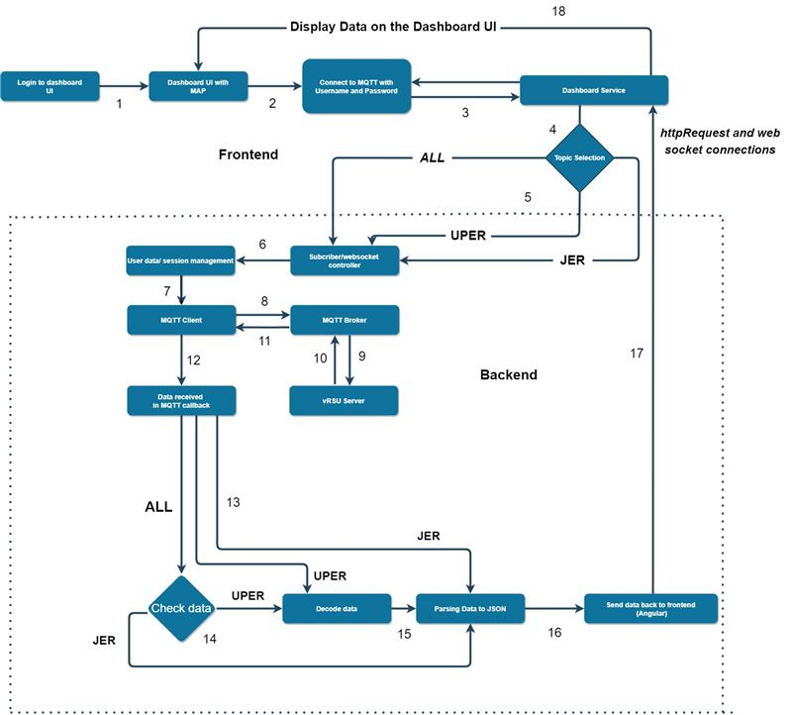
Step 1. User login with valid username and password.
Step2. After successful login, user routes to dashboard UI (map view) with unique session id.
Step 3. After successful login, user connects to MQTT server and subscribe the topic name using dashboard service Rest endpoint.
Step 4. While connecting to MQTT server the flow goes to dashboard service which is used to integrate with backend APIs.
Step 5. After subscribing the topic name, we receive the categorized data as below:
- JER data
- UPER data
- All data (Wildcard)
Step 6. For subscribing the topic name in Step 5, we are using WebSocket/subscriber controller
Step 7. It checks here for unique user session id in local Storage of application which further need to send to backend service in step 8.
Step 8. After identifying the unique user session id, it creates the MQTT connection in which we are using paho MQTT client to connect with MQTT broker.
Step 9. MQTT client sends the corresponding topic name to MQTT broker so that it can get data from the vRSU server.
Step 10. MQTT broker makes the connection with the vRSU server and creates a bridge between MQTT client and vRSU server to subscribe the required data.
Step 11. VRSU server authenticate the user and provide the subscribed data to MQTT broker.
Step 12. MQTT client sends the data to MQTT callback in backend service.
Step 13. MQTT callback receives data which further divided as follows:
- If JER data subscribed: If JER data is subscribed then it is converted to JSON object and send to frontend using WebSocket.
- If UPER data subscribed: If UPER data is subscribed then it is decoded using ASN library and send to frontend using WebSocket.
Step 14. If All (Wildcard) data subscribed then we check the topic type and following cases are performed:
- If JER data subscribed: If JER data is subscribed then it is converted to JSON object and send to frontend using WebSocket.
- If UPER data subscribed: If UPER data is subscribed then it is decoded using ASN library and send to frontend using WebSocket.
Step 15. This is the decoding stage where we decode the received string data.
Step 16. It is converting the decoded string data from Step 15 to a Json object.
Step 17. In this stage we send Json object (which we got from Step 16 )data to frontend through WebSocket.
Step 18. After getting data in the frontend, we show it to the user in dashboard UI with MAP and in other components.
Below are the types of messages after decoding:
Messages are being decoded from backend and sent to Frontend through web-socket connection. Below are the structures of various messages along with the field that are being used in frontend.
After decoding we get data in string format which we parse and store in a json object as below:
JsonObject jsonObjectOutput = (JsonObject) jsonParser.parse(<Received_JSON_STRING>);
And this object we send to frontend, then frontend gets the data format as below:
- PSM: The Personal Safety Message (PSM) is used to broadcast safety data regarding the kinematic state of various types of Vulnerable Road Users (VRU), such as pedestrians, cyclists, or road workers. Data items which are optional are included in a PSM as needed according to policies that are beyond the scope of this standard.
Description of the fields of above attached PSM data, that are being consumed by frontend.
Field Name | Value | Use Case
id | 000006A9 | Data id to show in UI.
position | {  "lat": 284434417,  "long": 770549838  } | Used for attaching marker in the map based on latitude and longitude.
speed | 0 | Speed of pedestrian.
heading | 67 | It shows in which direction a pedestrian is moving.
type | PSM | Type of data.

- BSM: The basic safety message (BSM) is used in a variety of applications to exchange safety data regarding vehicle state. This message is broadcast frequently to surrounding vehicles with data content as required by safety and other applications. Transmission rates are beyond the scope of this standard, but a rate 10 times per second is typical when congestion control algorithms do not prescribe a reduced rate.

Description of the fields of above attached PSM data, that are being consumed by frontend.
Field Name | Value | Use Case
id | 000006A9 | Id of the vehicle to be shown in UI.
speed | 0 | Speed of a vehicle.
heading | 71 | It shows in which direction a vehicle is moving.
type | BSM | Type of data
subtype | TRUCK | Subtype of a vehicle
topicType | JER | Topic type eg. JER/UPER

- EVA: The emergency vehicle alert message is used to broadcast warning messages to surrounding vehicles that an emergency vehicle (typically an incident responder of some type) is operating in the vicinity and that additional caution is required. The message itself is built on the original ATIS roadside alert message which in turn uses the common ITIS phrase list to both describe the event and provide advice and recommendation for travelers.

Description of the fields of above attached PSM data, that are being consumed by frontend.
Field Name | Value | Use Case
position | "long": "770549925",  "lat": "284434419", | Used for attaching marker in the map based on latitude and longitude.
heading | 66 | It shows in which direction a vehicle is moving.
speed | {  "speed": "0"  } | Speed of a vehicle.
id | 000006A9 | Id of the vehicle to be shown in UI.
type | EVA | Type of data
topicType | JER | Topic type eg. JER/UPER

- SPaT: The signal phase and timing (SPAT) message is used to convey the current status of one or more signalized intersections. Along with the MSG_MapData message (which describes a full geometric layout of an intersection), the receiver of this message can determine the state of the signal phasing and when the next expected phase will occur.MAP: The MapData message is used to convey many types of geographic road information. At the current time, its primary use is to convey one or more intersection lane geometry maps within a single message. The map message content includes such items as complex intersection descriptions, road segment descriptions, high speed curve outlines (used in curve safety messages), and segments of roadway (used in some safety applications).
Description of the fields of above attached PSM data, that are being consumed by frontend.
Field Name | Value | Use Case
id | 731 | ID to match with MAP data to get lat, long from MAP data.
signalGroup | 2
state-time-speed | {"eventState":"protected-Movement-Allowed",  "timing":{  "minEndTime":33897,  "maxEndTime":34057,  "likelyTime":33977,  "confidence":15} | Used for showing signal lights status.
type | SPAT | Type of data

- MAP: Message conveys the description of one or more geographic areas or intersections. The contents of this message involve defining the details of indexing systems that are in turn used by other messages to relate additional information (for example, the signal phase and timing via the SPAT message) to events at specific geographic locations on the roadway.

Description of the fields of above attached PSM data, that are being consumed by frontend.
Field Name | Value | Use Case
name | Unitech Cyber Park | Used for showing the traffic signal place name in UI.
refPoint | {"lat":285059028,"long":770957442} | To get the exact location of traffic signal for drawing marker in map.
type | MAP | Type of data

2.3 Dependencies and Change Impacts

2.3.1 System Dependencies
<List and identify any dependencies the proposed solution will have on other systems.>
We are using google APIs for geocoding and showing maps.
In order to use google APIs, we need a valid key for google API which we can get from google account.
To set up the google key we have add below section in angular app.module.ts file

imports: [

AgmCoreModule.forRoot({
apiKey: 'API_KEY',
libraries: ['places', 'drawing', 'geometry'],
}),
],

Below are the APIs that we are using:
google.maps.MapTypeId : This API is used to show the map of different type for ex. Roadmap or hybrid.
google.maps.Geocoder : This is used to get the address from the latitude and longitude value.

2.3.2 Change Impacts
As we are using google APIs mentioned in Section 2.3.1
There are 2 google APIs, if there is any change in these APIs then we may have below change impact.
- The address that we are showing in UI based on latitude and longitude that will be impacted.
- Google map display can be impacted on the application main screen.

Functional Specifications
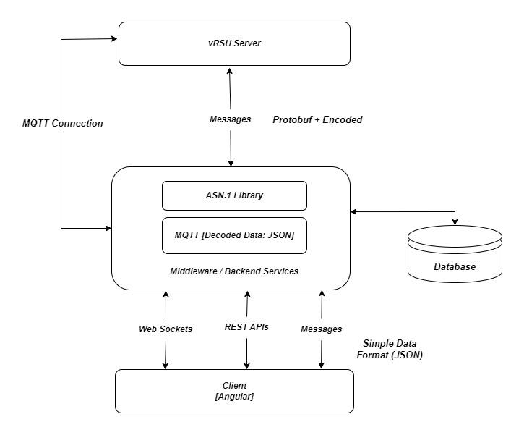

VRSU: It is the MQTT (Standard messaging protocol for IoT). Multiple publishers are publishing the data to MQTT through an android application. It serves as messaging queue service which is connected to Middle Ware or Backend Services.

MiddleWare or Backend Services: This layer is connected with VRSU through a very lightweight publish/subscribe system. It contains ASN Library, MQTT using decoded data, Backend services.

ASN library: Abstract Syntax Notation, is an International Standards Organization (ISO) data representation format used to achieve interoperability between platforms. It permits computers and software systems of all types to reliably exchange both the data structure and content.

MQTT decoded data: When subscribed to a particular topic, messages are being listened by backend services. All these messages are decoded here for further use.

Backend services: It contains the REST APIs endpoints. Description of these services are mention in below table.

Client (Angular): It is a web-based application reacts as a client for backend services. It provides detailed option for pedestrian counts, total emergency counts, total general vehicle. It communicates with Backend service/middleware through REST APIs or WebSocket.

Database: As of now, there is no database but in upcoming implementation we are going to add Mongodb.

Backend Rest Controllers | Rest Endpoints | Description
SubscriberController | /login | Used to login to dashboard UI using username and password.
 | /mqttConnectionCheck | It is a rest endpoint service used to connect MQTT.
 | /subscribeToTopic | Used to subscribe a particular topic in MQTT for message callbacks.
 | /disconnect | Used to disconnect from MQTT connection.
WebSocketController | /checkConnectivity | It is used by frontend to get the current user session id after every 5 minutes.
 | /notify | It used to update the subscribed topic in the current user session.
MqttCallback | messageArrived | This is a callback event which is being called on every message published in MQTT
 | connectionLost | When the connection to MQTT is lost, this callback event is invoked.

3.1 <User Flow>

3.1.1 Use case
<Map the functional requirement to one or more use cases mentioned in the Business Requirements document. If the use case is not described in detail in the Business Requirements document, describe the use case here. This typically includes the element s in the following table.>

UC-1 | < View All Vehicle Information >
Primary Actor(s) | < Admin, Vehicles, Emergency Vehicles & Pedestrians>
Stakeholders and Interest | Admin and internal users for data analysis
Trigger | <Data streaming from Vehicles, Emergency Vehicles & Pedestrians >
Pre-conditions | <Connection to VZ server is established by primary actors>
Post-conditions | <Display data for analytics >
Main Success Scenario | Data visible for below messages  - BSM  - PSM  - EVA
Extensions | No Extensions
Priority | <High>
Special Requirements | <NA>
Open Questions | <NA>

UC-2 | < General Vehicle Information >
Primary Actor(s) | < Admin, Vehicles >
Stakeholders and Interest | Admin and internal users for data analysis
Trigger | <Data streaming from Vehicles >
Pre-conditions | <Connection to VZ server is established by primary actors>
Post-conditions | <Display data for analytics >
Main Success Scenario | Data visible for BSM
Extensions | No Extensions
Priority | <High>
Special Requirements | <NA>
Open Questions | <NA>

UC-3 | < Pedestrian Information >
Primary Actor(s) | < Admin, Pedestrian >
Stakeholders and Interest | Admin and internal users for data analysis
Trigger | <Data streaming from Pedestrian ,cyclist>
Pre-conditions | <Connection to VZ server is established by primary actors>
Post-conditions | <Display data for analytics >
Main Success Scenario | Data visible for PSM
Extensions | No Extensions
Priority | <High>
Special Requirements | <NA>
Open Questions | <NA>

UC-4 | < Emergency Vehicle Information >
Primary Actor(s) | < Admin, Emergency Vehicle >
Stakeholders and Interest | Admin and internal users for data analysis
Trigger | <Data streaming from Emergency Vehicles >
Pre-conditions | <Connection to VZ server is established by primary actors>
Post-conditions | <Display data for analytics >
Main Success Scenario | Data visible for EVA
Extensions | No Extensions
Priority | <High>
Special Requirements | <NA>
Open Questions | <NA>

UC-5 | < Detailed View Information>
Primary Actor(s) | < Admin, Vehicles, Emergency Vehicles & Pedestrians >
Stakeholders and Interest | Admin and internal users for data analysis
Trigger | <Data streaming from Vehicles, Emergency Vehicles & Pedestrians
Pre-conditions | <Connection to VZ server is established by primary actors>
Post-conditions | <Display data for analytics >
Main Success Scenario | Data visible for below messages  - BSM  - PSM  - EVA
Extensions | No Extensions
Priority | <High>
Special Requirements | <NA>
Open Questions | <NA>

UC-6 | < Signal phase and timing information >
Primary Actor(s) | < Admin, Signal Information >
Stakeholders and Interest | Admin and internal users for data analysis
Trigger | <Data streaming from Traffic lights/Signals>
Pre-conditions | <Connection to VZ server is established by primary actors>
Post-conditions | <Display data for analytics >
Main Success Scenario | Data visible for Signal Locators
Extensions | No Extensions
Priority | <High>
Special Requirements | <NA>
Open Questions | <NA>

Mock-up
It includes 3.1.2 Use case (UC-1, UC-2, UC-3, UC-4)
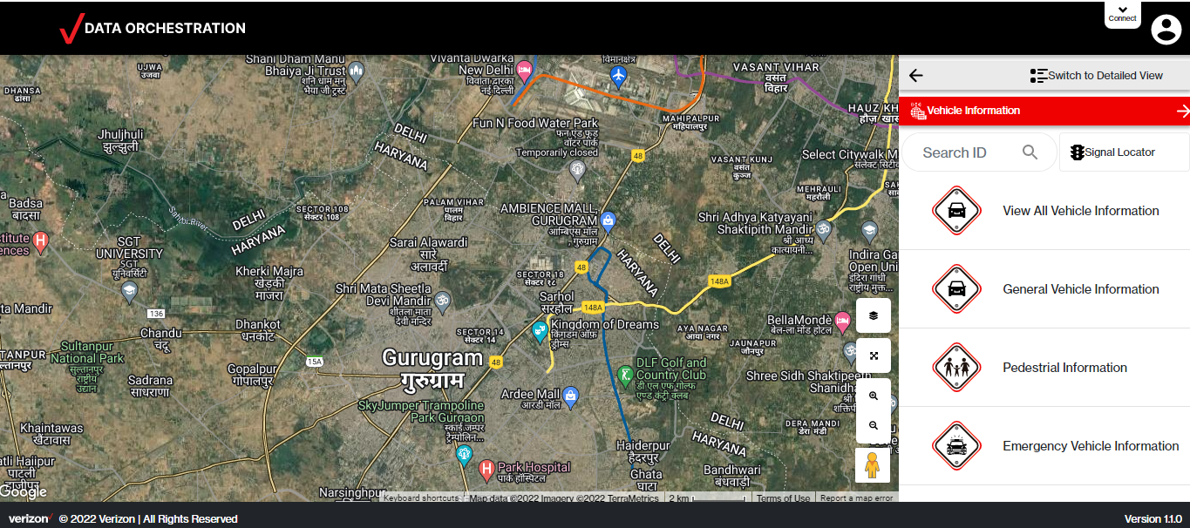
It includes 3.1.2 Use case (UC-5)
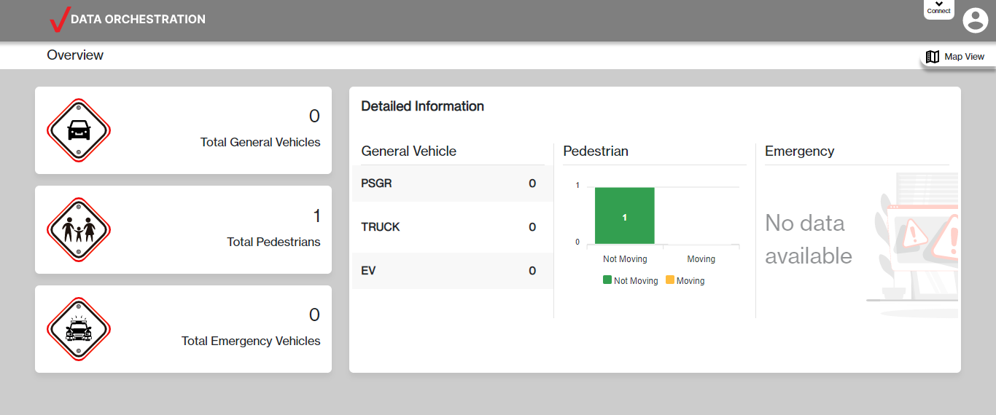
It includes 3.1.2 Use case (UC-6)
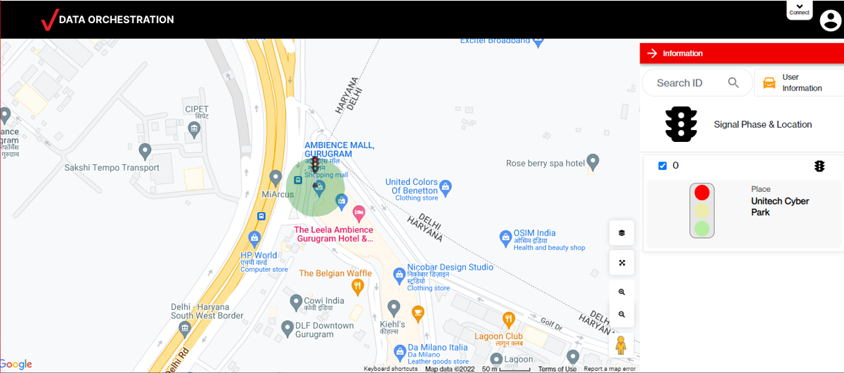

3.1.4 Functional Requirements
<Describe the page level details that are not captured in section 3.1.5 below. These may include any requirements related to Navigation Menu, Actions, transaction status, verification and validation requirements etc.>
Apply Button: After entering URL, username and password, user clicks Apply button to establish MQTT connection.
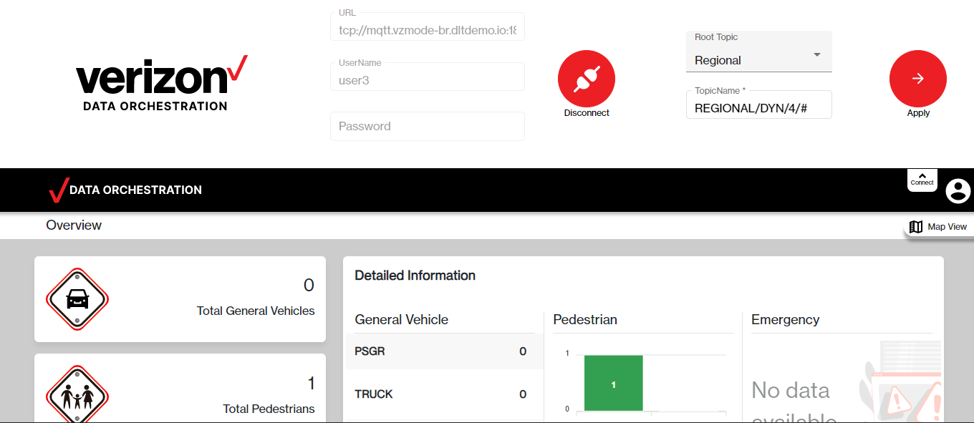
After successful connection, user will see the below screen
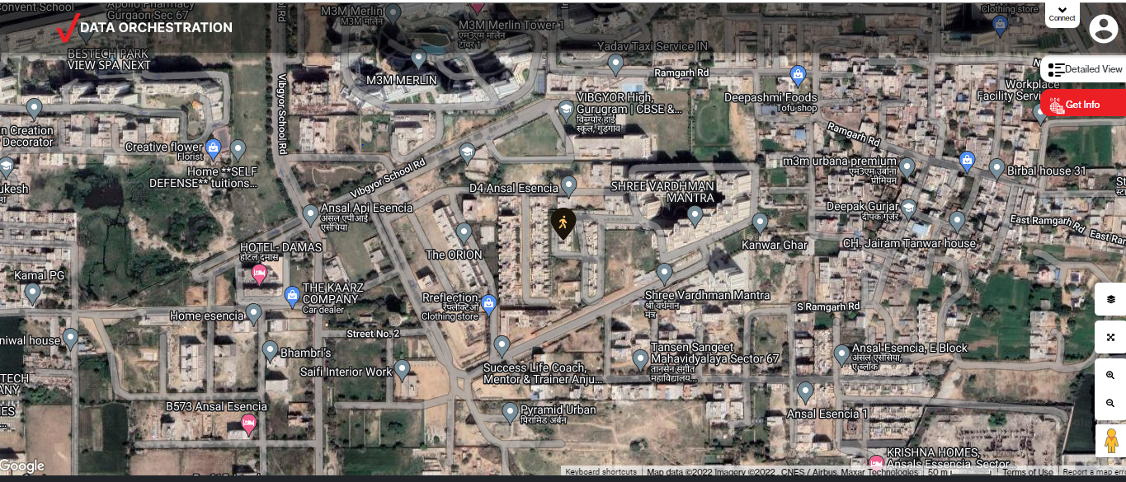
It contains the 2 views:
- Detailed view
- Get Info
- Signal Locator
Detailed view:
If user clicks on detailed view, user will able to see the below screen:
Above view contained the count information for general vehicles, total pedestrian and total emergency vehicles.
It also contains the information of the emergency vehicle along with the address or last location of the vehicle.
Get Info:
After selection of this section, user gets the below view with multiple options
- View All Vehicle Information: This gives information of all types of vehicles, whether its general, emergency vehicle or pedestrian information.
- General Vehicle Information: This only filters out the data for the general vehicle, which technical contains all the BSM type messages from the MQTT. (For more info. Section 2.3)
- Pedestrian Information: This only filters out the data for the pedestrian, which technical contains all the PSM type messages from the MQTT. (For more info. Section 2.3)
- Emergency Vehicle Information: This only filters out the data for the emergency vehicle like ambulance, which technical contains all the EVA type messages from the MQTT. (For more info. Section 2.3)

Signal Locator:

- In signal locator panel we can see all data regarding traffic signals
- It will interpret the SPaT data from MQTT
- We also can see the live signal status.

3.1.5 Field level specifications
All the field data elements related to the functional requirement in both tables below.

Form Elements: Login
Field Label | UI Control | Mand? | Editable | Data Type | Value Set | Default Value | Data Example | Data Source
User name | textbox | No | Yes | Alpha-numeric | none | BLANK | admin | User entry
Password | textbox | No | yes | Alpha-numeric | none | BLANK | admin | User entry

Form Elements: MQTT Connection
Field Label | UI Control | Mandatory | Editable | Data Type | Value Set | Default Value | Data Example | Data Source
URL | textbox | Yes | yes | URL | none | tcp://mqtt.vzmode-br.dltdemo.io:1883 | tcp://mqtt.vzmode-br.dltdemo.io:1883 | First Login: Automatically filled  After disconnection: User entry
User name | textbox | yes | Yes | Alpha-numeric | none | user3 | user3 | First Login: Automatically filled  After disconnection: User entry
Password | textbox | yes | yes | Alpha-numeric | none | ********* | dEWVyghBYgvygV | First Login: Automatically filled  After disconnection: User entry

Form Elements: Topic Subscription
Field Label | UI Control | Mandatory | Editable | Data Type | Value Set | Default Value | Data Example | Data Source
Root Topic | dropdown | Yes | no | Sting | Regional  Individual | Regional | Regional | User selection
Topic Name | textbox | yes | Yes | Alpha-numeric | none | REGIONAL/DYN/4/# | REGIONAL/DYN/3/+/+/# | User entry

Buttons, Links and Icons:
Button, Link, Icon Label | OnClick Event | Other Event | Visible | Enabled Vs Disabled | Navigate To | Validation | Dependencies
Button: Login | It validates the username and password | NA | yes | Enable always | After successful authentication, navigates to user dashboard | If username and password do no match its shows a error toast message. | Its dependent on Form Elements: Login
Button: Connect | It establishes the MQTT connection | NA | Yes, By default  If user leaves any field empty Form Elements: MQTT Connection, then it is not visible | Enable | Remains to User Dashboard page | It establishes the MQTT connection with the details provided by user using REST endpoint | Its dependent on Form Elements: MQTT Connection
Button: Apply | It subscribes to the user entered topic | NA | Yes, By default  If user leaves any field empty Form Elements: Topic Subscription, then it is not visible | Enable | Remains to User Dashboard page | It subscribes to the user entered topic and provides data to frontend using WebSocket. | Its dependent on Form Elements: Topic Subscription
Button: Disconnect | It disconnects the user from MQTT connection | NA | Hidden, by default  Only visible after the successful connection to MQTT. | Enable | Remains to User Dashboard page | It disconnects the user from MQTT and provides no data to frontend in WebSocket. | Only visible after the successful connection to MQTT.
Button: Setting | No Action | NA | yes | Enable | No action | No validation | No dependency
Button: Logout | It logout the user from the current session | NA | yes | Enable | Route user to login page | No validation | No dependency
Label: Detailed View | It routes us to detailed UI | NA | yes | Enable | It directs us to detailed UI. | No validation | No dependency
Label: Get Info | It opens a panel with more detailed information | NA | yes | Enable | It brings up a panel with detailed information. | No validation | No dependency

System Configurations
<Provide an overview of all the steps or the set ups required to configure an application/program. Also state the intent or purpose behind each set up or configuration. Discuss the possible alternatives, customizations, workaround’s, conditions and dependencies in a particular configuration. In case of Oracle applications, please list all applicable BR100’s or Application set up documents>

Backend | Frontend
Java 11 | Angular 14.2.4 or above Angular version 9
ASN library | Nodejs 16.17.0 or above Nodejs 14
MQTT | Nginx
Sprint boot (Version 2.5.X)

Backend Setup
This section should is to document:
- Specific development tools, compilers or suggested IDEs (Eclipse) that are used for the application.
- Source control is performed using GIT.
- Clone the project from Git repository
git clone https://github.com/5GRealityLab/do_dashboard_ui.git
git checkout main
cd vrsu-subscriber-manger

Import the project in eclipse using maven import
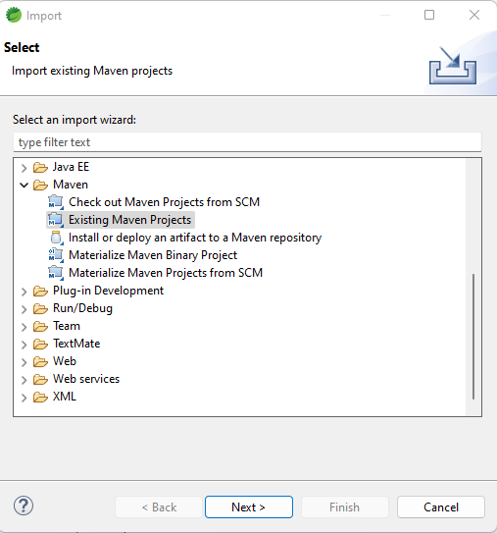
Let the project build automatically (when completes it will be notified in bottom right cornor.)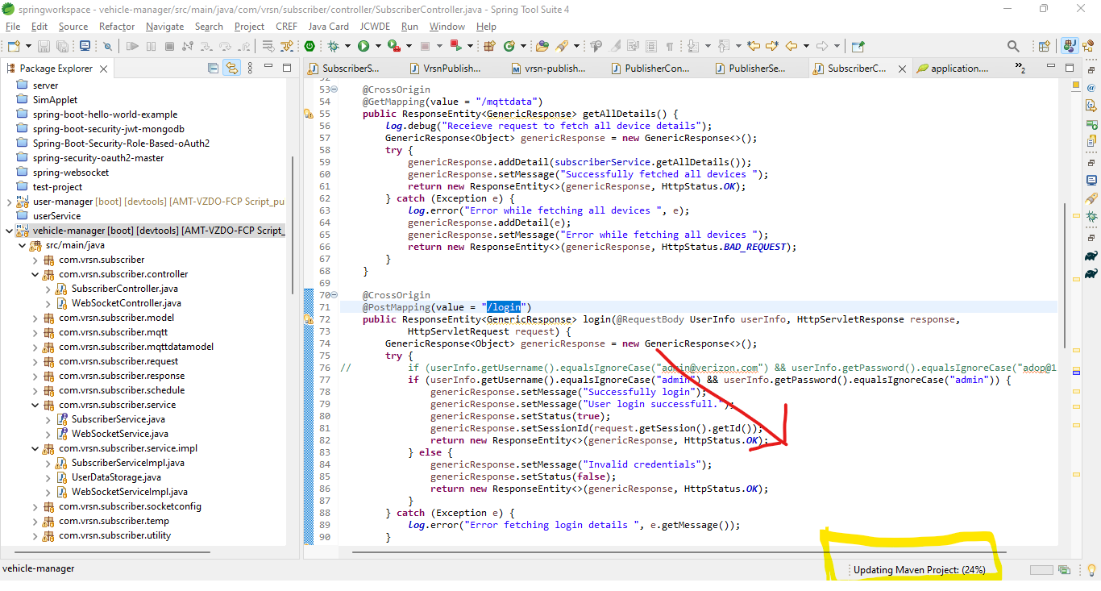
Build the service, use below commands:
mvn clean install
mvn spring-boot:run

Frontend Setup
Step 1: Install node using https://nodejs.org/en/download/

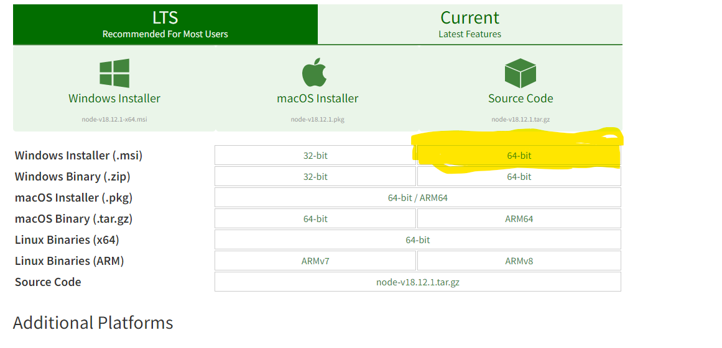

Step 2: Install downloaded .msi file.

Step 3: setup the path in environment variable.
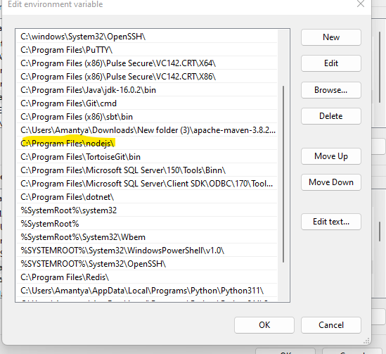

Step 4: Clone the project using below git command:
Git clone https://github.com/5GRealityLab/do_dashboard_ui.git

Step 5: Checkout development branch using
Git checkout main

Step 6: Pull the latest code
git pull

Step 7: cd hum-verizon-ui

Step 8: Install all the packages, using below command
npm install -f

Step 9: Start the server using below command
npm start

Step 10: Open browser, go to localhost:4200/

Step 11: Run ng build command to get the deployable output in dist folder.

Exception Handling/ Error Reporting
<This is where you can explain the error conditions/Exceptions that normally happen in Interfaces or cross flow system integrations. Explain the nature of exception, Error Id, Root cause of the error and also the strategy to handle the scenario. You can also indicate if there are any concurrent programs designed to automatically handle the error records or error conditions. State if there are any error reports generated or notifications utilized to alarm the support teams and system Administrators during the interface failures or outages>

Rest Error Codes | Error | Cause | Solution Strategy
500,504 | Something went wrong | Backend system is down or the resources are unavailable | Monitor all the resources are up and running in healthy state.
400 | Bad request | When there is some bad data passed in any form before submission. | User will see a error toast and has to pass the correct data is required format

Open Issues
Issue ID | Issue | Raised By | Raised On | Solution/ Decision | Resolved By | Resolved On | Status

Miscellaneous

Introduction To ASN.1
- Abstract Syntax Notation One (ASN.1) is a standard interface description language for defining data structures that can be serialized and deserialized in a cross-platform way.
- It is broadly used in telecommunications and computer networking, and especially in cryptography.
- Protocol developers define data structures in ASN.1 modules, which are generally a section of a broader standards document written in the ASN.1 language.
- ASN.1 is both human-readable and machine-readable, an ASN.1 compiler can compile modules into libraries of code, codecs, that decode or encode the data structures.
In the application we are using 2 encoding rules.
- UPER (Unaligned Packed Encoding Rules)
- JER (JSON Encoding Rules)

UPER: This Unaligned Packed Encoding are the most compact encoding rules. The goal of PER is to create smaller encodings. An advantage of using PER is the way it encodes data by examining constraints. PER does not send the Tag of the TLV since the order in which components of the message occur is known. PER also does not send the Length of the TLV if the Value has a fixed length. PER also uses additional information from the ASN.1 message description to eliminate redundant information from the Value portion of the TLV, thus making PER messages quite compact and suitable for environments in which bandwidth conservation is important.
For creation of UPER data, first we need to create a schema .
Let’s say my schema is,
BEGIN
FooBar ::= SEQUENCE {
Foo INTEGER (-512..511),
Bar INTEGER (-512..511)
}
END

Now, In case we need to encode below data:
test FooBar ::=
{
Foo 10,
Bar -10
}

It will be encoded as:
HEX: 0x829F60
BIN: 100000101001111101100000

Although, in our application we are directly using the ASN.1 libraries APIs to encode or decode the data.

JER: This JSON encoding rules was designed to allow applications to represent any ASN.1 value in JavaScript Object Notation (JSON). For example, an application that receives BER- or PER-encoded messages conforming to a certain ASN.1 schema will be able to re-encode the messages in JSON. This capability can be used to exchange data with other applications that do not understand ASN.1 but know how to parse or write JSON.
Below is the example of JER data for MAP being published to MQTT.

Map & SPAT Data Creation Summary
1.Create parent MAP
- 1. Reference point at center of intersection
- 2. Verified point at known accurate location
- 3. Configure intersection data (name, speed limit, etc.)
- 4. Save file to computer
2. Create child MAP
- 1. Load parent MAP created in 1
- 2. Draw vehicle lanes connecting to intersection, from stop bar backwards
- 3. Group vehicle lanes into approaches
- 4. Draw crosswalks
- 5. Fill in vehicle lane details
- 6. Fill in approach details
- 7. Fill in crosswalk details
- 8. Configure “connects to” values and signal groupings for all vehicle lanes
- 9. Save file to computer

